Objective Questions

1. Are there any tables with duplicate or missing null values? If so, how would you handle them?

* There were no missing/duplicate values

1. What is the distribution of user activity levels (e.g., number of posts, likes, comments) across the user base?

* Likes: 7623

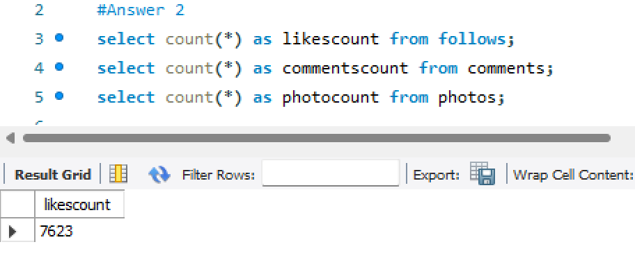

* Comments: 7488

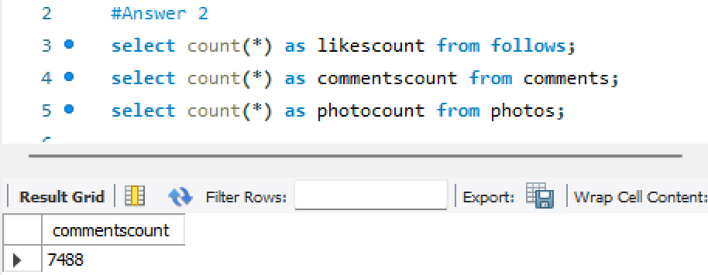

* Photos: 257

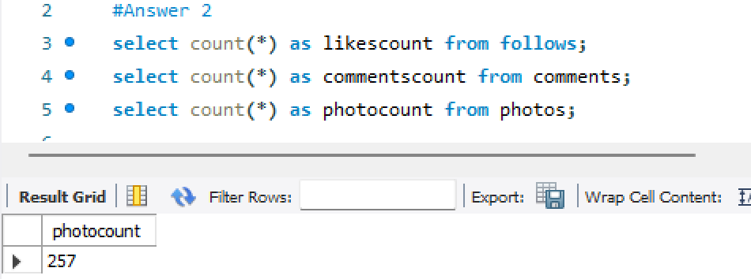

1. Calculate the average number of tags per post (photo_tags and photos tables).

* 2.6368

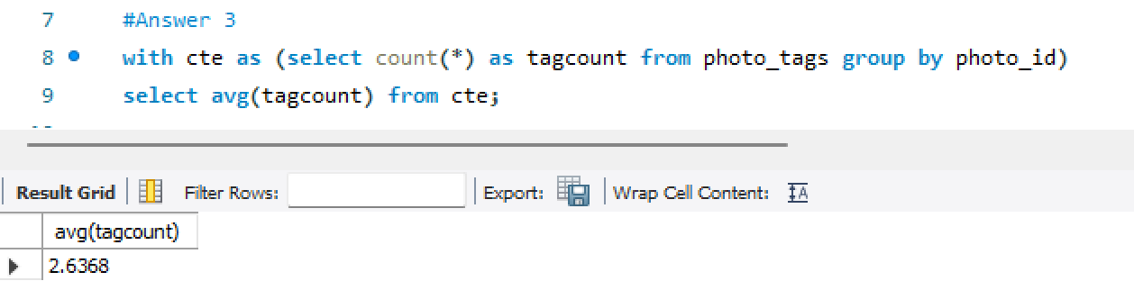

1. Identify the top users with the highest engagement rates (likes, comments) on their posts and rank them.

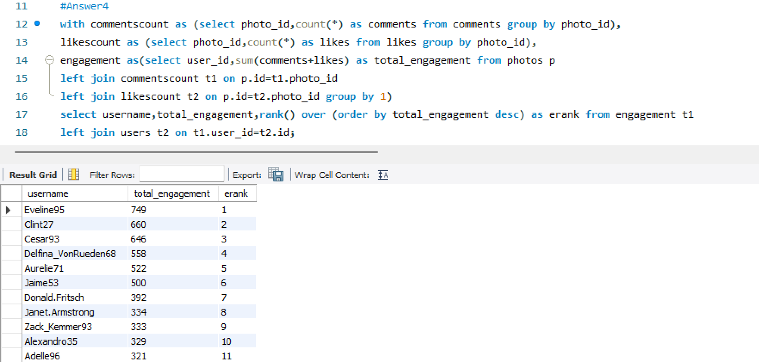

1. Which users have the highest number of followers and followings?

* Many seems to have same number of followers and followee 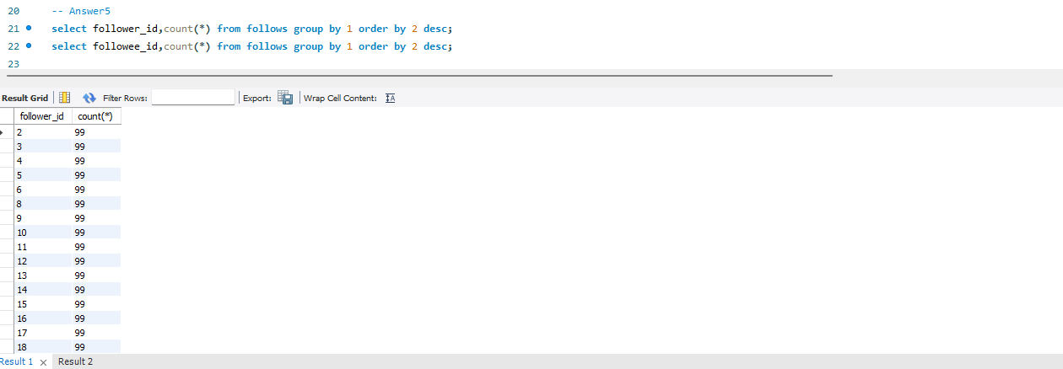 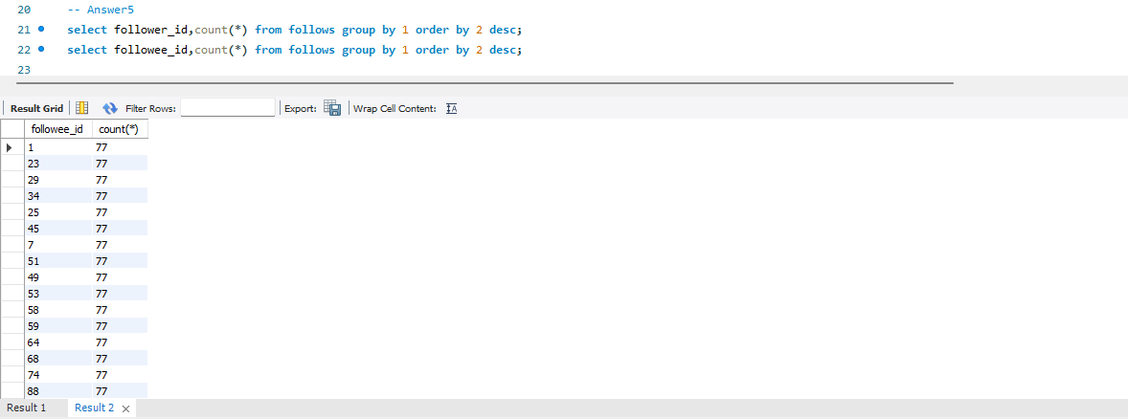

1. Calculate the average engagement rate (likes, comments) per post for each user.

* Implemented using group by and CTE

**Maggie_Doyle** has the highest average engagement

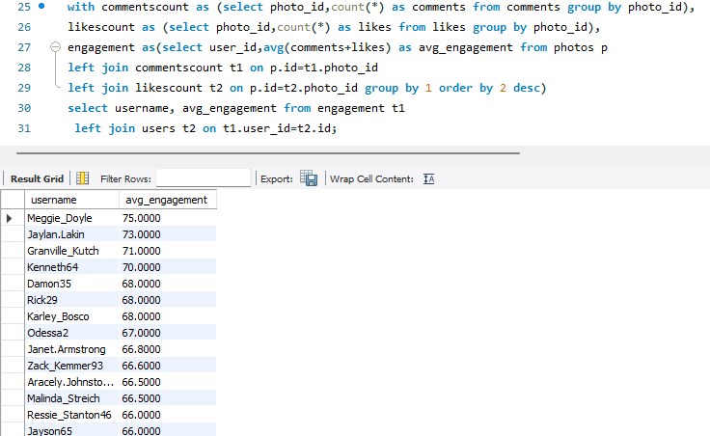

1. Get the list of users who have never liked any post (users and likes tables)

* The users with who have not like any post are

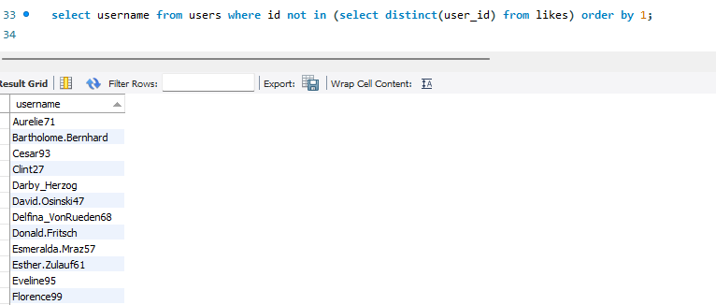

* Aurelie71
* Bartholome.Bernhard
* Cesar93
* Clint27
* Darby_Herzog
* David.Osinski47
* Delfina_VonRueden68
* Donald.Fritsch
* Esmeralda.Mraz57
* Esther.Zulauf61
* Eveline95
* Florence99
* Franco_Keebler64
* Hulda.Macejkovic
* Jaime53
* Jessyca_West
* Kasandra_Homenick
* Kenton_Kirlin
* Linnea59
* Mariano_Koch3
* Morgan.Kassulke
* Pearl7
* Tierra.Trantow

1. How can you leverage user-generated content (posts, hashtags, photo tags) to create more personalized and engaging ad campaigns?

* To create more personalized and engaging ad campaigns using user-generated content, we can analyze the data from posts, hashtags, and photo tags to identify user interests. For instance, by using the **photos** and **photo_tag** tables, we can determine the individuals present in specific photos, and by examining the **tags** table, uncover their interests through associated hashtags like #food, #photography, and #beauty. With this information, users can be segmented based on their interests, and ad content can be designed tailored to each group's preferences, ensuring targeted ad delivery.

1. Are there any correlations between user activity levels and specific content types (e.g., photos, videos, reels)? How can this information guide content creation and curation strategies?

* Upon analysing the data, we found it to be inadequate as there is no data regarding videos and reels. The dataset only includes information about photos.

1. Calculate the total number of likes, comments, and photo tags for each user.



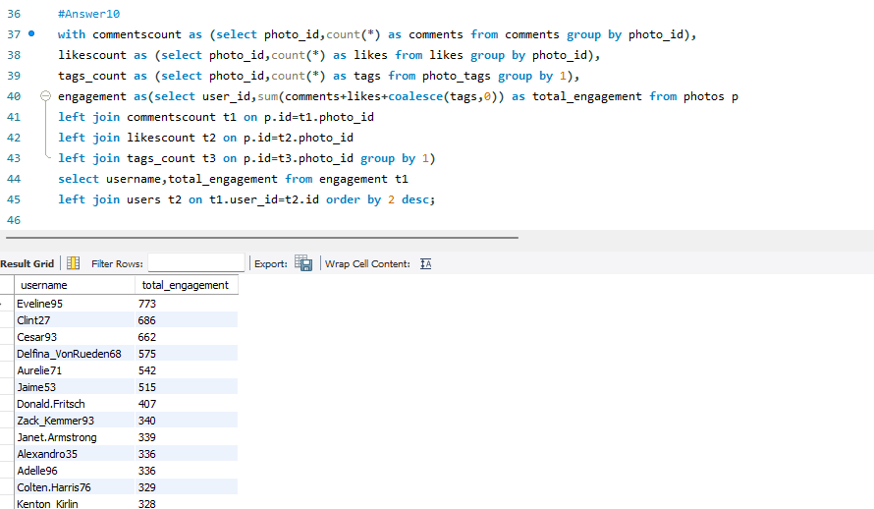

1. Rank users based on their total engagement (likes, comments, shares) over a month.

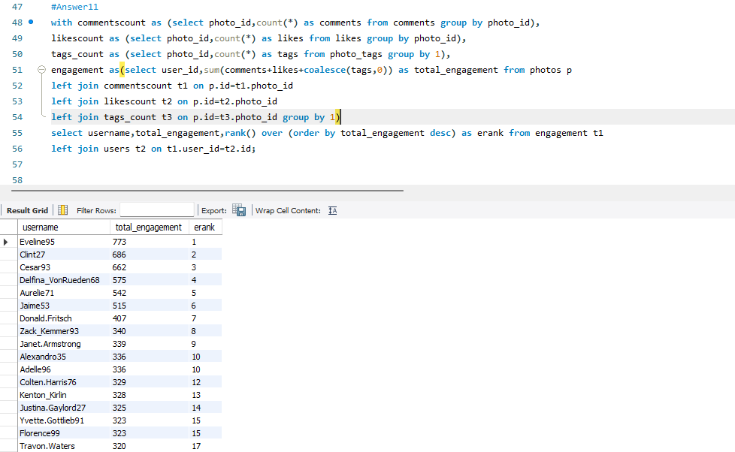

Note: All the data available was of one month only ie July

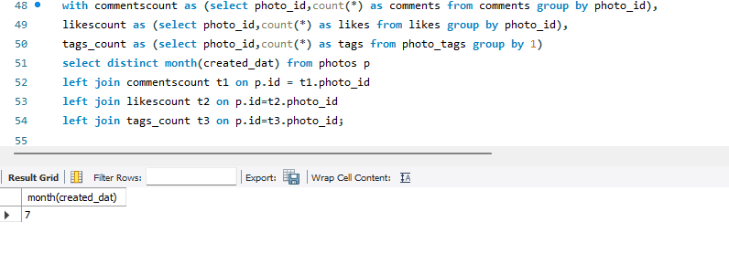

1. Retrieve the hashtags that have been used in posts with the highest average number of likes. Use a CTE to calculate the average likes for each hashtag first.

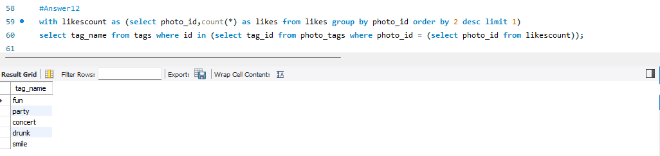

Note: Analysed for post with the highest number for like rather than highest average number of likes because the average like for each photo will always be one.

1. Retrieve the users who have started following someone after being followed by that person?

* On analysing the data it seem that all the user follower each at the same time.  
  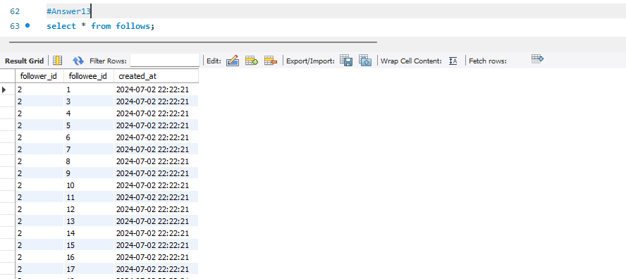

So we cannot retrieve users that started following someone after being followed by that person.

Subjective Questions

1. Based on user engagement and activity levels, which users would you consider the most loyal or valuable? How would you reward or incentivize these users?

* On analysing user engagement and activity level, we can say that the below users are most valuable and loyal as they have posted the most pictures and have the highest engagement. The selected users are **Eveline95**, **Cesar93** and **Clint27**

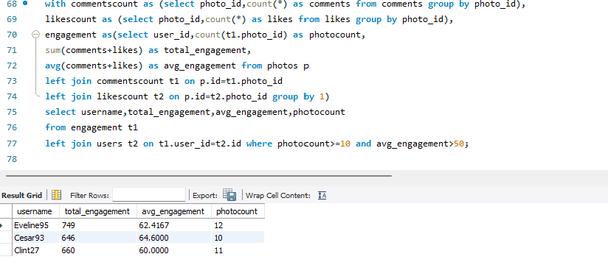

They can be rewarded by selecting them for influencer marketing campaigns as a potential brand ambassador who could help promote Instagram's initiatives or events.

1. For inactive users, what strategies would you recommend to re-engage them and encourage them to start posting or engaging again?

* Below are the list of user who have not posted any photo or does have any likes or comments.

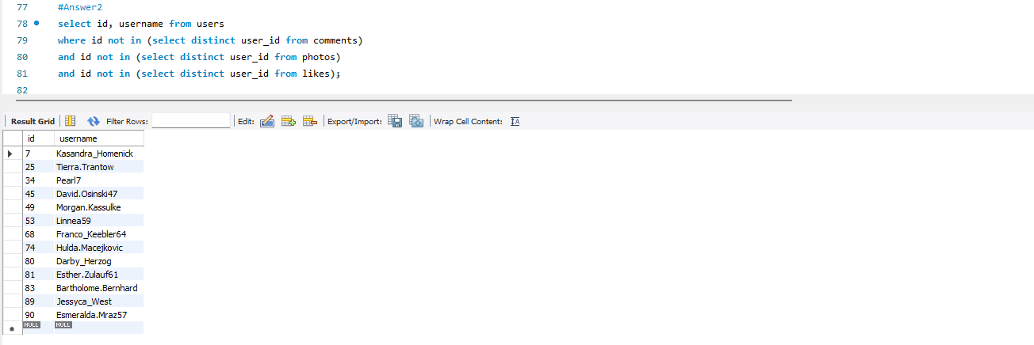

|  |  |
| --- | --- |
| **id** | **username** |
| 7 | Kasandra_Homenick |
| 25 | Tierra.Trantow |
| 34 | Pearl7 |
| 45 | David.Osinski47 |
| 49 | Morgan.Kassulke |
| 53 | Linnea59 |
| 68 | Franco_Keebler64 |
| 74 | Hulda.Macejkovic |
| 80 | Darby_Herzog |
| 81 | Esther.Zulauf61 |
| 83 | Bartholome.Bernhard |
| 89 | Jessyca_West |
| 90 | Esmeralda.Mraz57 |

We can take the following steps to encourage inactive user:

* **Email Campaigns:** Send personalized emails reminding users of the benefits of engaging with the platform. Highlight new features, popular discussions, or content they might be interested in.
* **In-App Notifications:** Use in-app notifications to draw their attention to relevant updates or content they have previously shown interest in.
* **Engaging Content:** Create and promote high-quality, engaging content that caters to the interests of your inactive users.
* **Personalized Recommendations:** Use algorithms to recommend content, groups, or connections that are highly relevant to each user.
* **Feedback Implementation:** Show that you are listening by implementing changes based on user feedback and communicating these changes.
* **Exclusive offers or incentives:** Offer special promotions or incentives for inactive users to encourage them to start posting or engaging again. This could include discounts, freebies, or exclusive access to premium features.
* **Highlight new content or features:** Showcase any new content or features that have been added to the platform since the user was last active. This can pique their interest and encourage them to start posting again.

1. Which hashtags or content topics have the highest engagement rates? How can this information guide content strategy and ad campaigns?

* Below are the top hashtags with most engagement

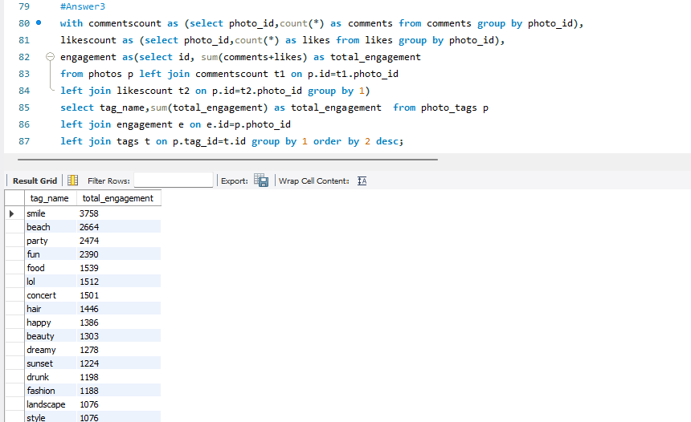

By analysing the most popular hashtags, we can provide the following insights:

* **Identify User Interests**: Analyzing popular hashtags reveals the topics and themes users are most engaged with. It Helps in understanding current trends and preferences among the user base.
* **Content Personalization**: Tailor content to align with the interests indicated by popular hashtags. Enhance user experience by delivering relevant and engaging content.
* **Trend Analysis**: Stay updated with emerging trends and shifts in user interests. Adjust content and marketing strategies dynamically to stay relevant.
* **Content Planning**: Plan and schedule content based on the analysis of hashtag popularity. Ensure a consistent flow of engaging and relevant content.
* **Community Building**: Foster a sense of community by creating content around popular hashtags. Encourage user interaction and participation around trending topics.
* **Enhanced Analytics**: Integrate hashtag analysis with other analytics for a comprehensive understanding of user behavior. Use data-driven insights to make informed decisions.

1. Are there any patterns or trends in user engagement based on demographics (age, location, gender) or posting times? How can these insights inform targeted marketing campaigns?

* Upon analysing the data, we found it to be inadequate as there is no data regarding age, location and gender as users. The dataset only includes information about username.

1. Based on follower counts and engagement rates, which users would be ideal candidates for influencer marketing campaigns? How would you approach and collaborate with these influencers?

* On analysing user engagement and follower counts (same for most users(refer objective answer 5)), we can say that the below users can be selected for influencer marketing campaigns as they have posted the most pictures and have the highest engagement. The selected users are **Eveline95**, **Cesar93** and **Clint27**



We can approach them via direct message or email and personalizing the message/email to show that we are genuinely interested in their content.

1. Based on user behavior and engagement data, how would you segment the user base for targeted marketing campaigns or personalized recommendations?

* We can enhance our personalized recommendations by following:-
* **Understanding User Interests**: Analyze hashtags used by users in their posts and photos they are tagged in. Gain insights into individual user preferences and interests.
* **Improved Personalized Recommendations**: Enhance user experience by providing content aligned with their interests.
* **Relevant Ad Delivery**: Develop personalized ads based on users' hashtag activity. It Increases ad relevance and likelihood of capturing user attention.
* **Enhanced User Engagement**: Personalized ads are more likely to drive higher engagement rates. Users are more inclined to interact with content that matches their interests.
* **Data-Driven Insights**: Leverage hashtag analysis for deeper insights into user behavior. Use these insights to make informed business and marketing decisions.
* **Enhanced Community Engagement**: Foster a sense of belonging by delivering content that reflects community interests. We should also encourage user participation through relevant content.
* **Continuous Feedback Loop**: Continuously adapt strategies based on evolving user interests and should take continuous feedback to refine recommendations and ads.

1. If data on ad campaigns (impressions, clicks, conversions) is available, how would you measure their effectiveness and optimize future campaigns?

* Measures for analysing the campaign
* **Metrics**: Track impressions, clicks, CTR, conversions, conversion rate, CPC, CPA, and ROAS.
* **Analysis**: Compare metrics against benchmarks.

We can use the below steps to optimize future campaign

* **Refine Targeting**: Focus on high-performing audience segments.
* **A/B Testing**: Test and choose the best ad creatives.
* **Budget**: Increase spend on effective campaigns.
* **Adjust Timing**: Optimize ad scheduling based on performance.
* **Monitor and Adjust**: Continuously review and tweak strategies.

1. How can you use user activity data to identify potential brand ambassadors or advocates who could help promote Instagram's initiatives or events?

* On analysing user engagement and follower counts(same for most users(refer objective answer 5)), we can say that the below users can be selected as an potential brand ambassadors or advocates who could help promote Instagram's initiatives or events as they have posted the most pictures and have the highest engagement. The selected users are **Eveline95**, **Cesar93** and **Clint27**



1. How would you approach this problem, if the objective and subjective questions weren't given?

* We would have approached with the following steps:-
* **Measure Engagement**:
* Track likes count and comments count for photos posted by each user.
* Identify the most active and popular users based on engagement metrics.
* **Identify Potential Influencers**:
* Analyse engagement data to pinpoint users with high interaction rates.
* Consider these users for future influencer marketing to promote events or products.
* **Hashtag Analysis**:
* Analyse the hashtags used by users when posting their photos.
* Identify the most active and popular users based on engagement metrics.
* **Personalized Recommendations**:
* Use hashtag analysis to understand user interests.
* Provide personalized content recommendations based on popular hashtags.
* **Targeted Advertising**:
* Develop recommended ads that align with user interests identified through hashtag analysis.
* Enhance ad relevance to improve user engagement and conversion rates.
* **Trend Identification**:
* Monitor hashtags to identify emerging trends and shifts in user interests.
* Adjust content and marketing strategies accordingly

.

* **User Segmentation**:
* Segment users based on their engagement levels and hashtag usage.
* Create targeted content and marketing campaigns for different user segments.
* **Data-Driven Decisions**:
* Leverage engagement and hashtag analysis for deeper insights into user behaviour.
* Use these insights to make informed business and marketing decisions.

1. Assuming there's a "User_Interactions" table tracking user engagements, how can you update the "Engagement_Type" column to change all instances of "Like" to "Heart" to align with Instagram's terminology?

* If there was a table "**User_Interactions**" with column **"Engagement_Type"** and we have to change all instances of "Like" to "Heart" to align with Instagram's terminology, we would use the below query.

UPDATE User_Interactions

SET Engagement_Type = “Heart”

WHERE Engagement_Type = “Like”;